

THE HERITAGE

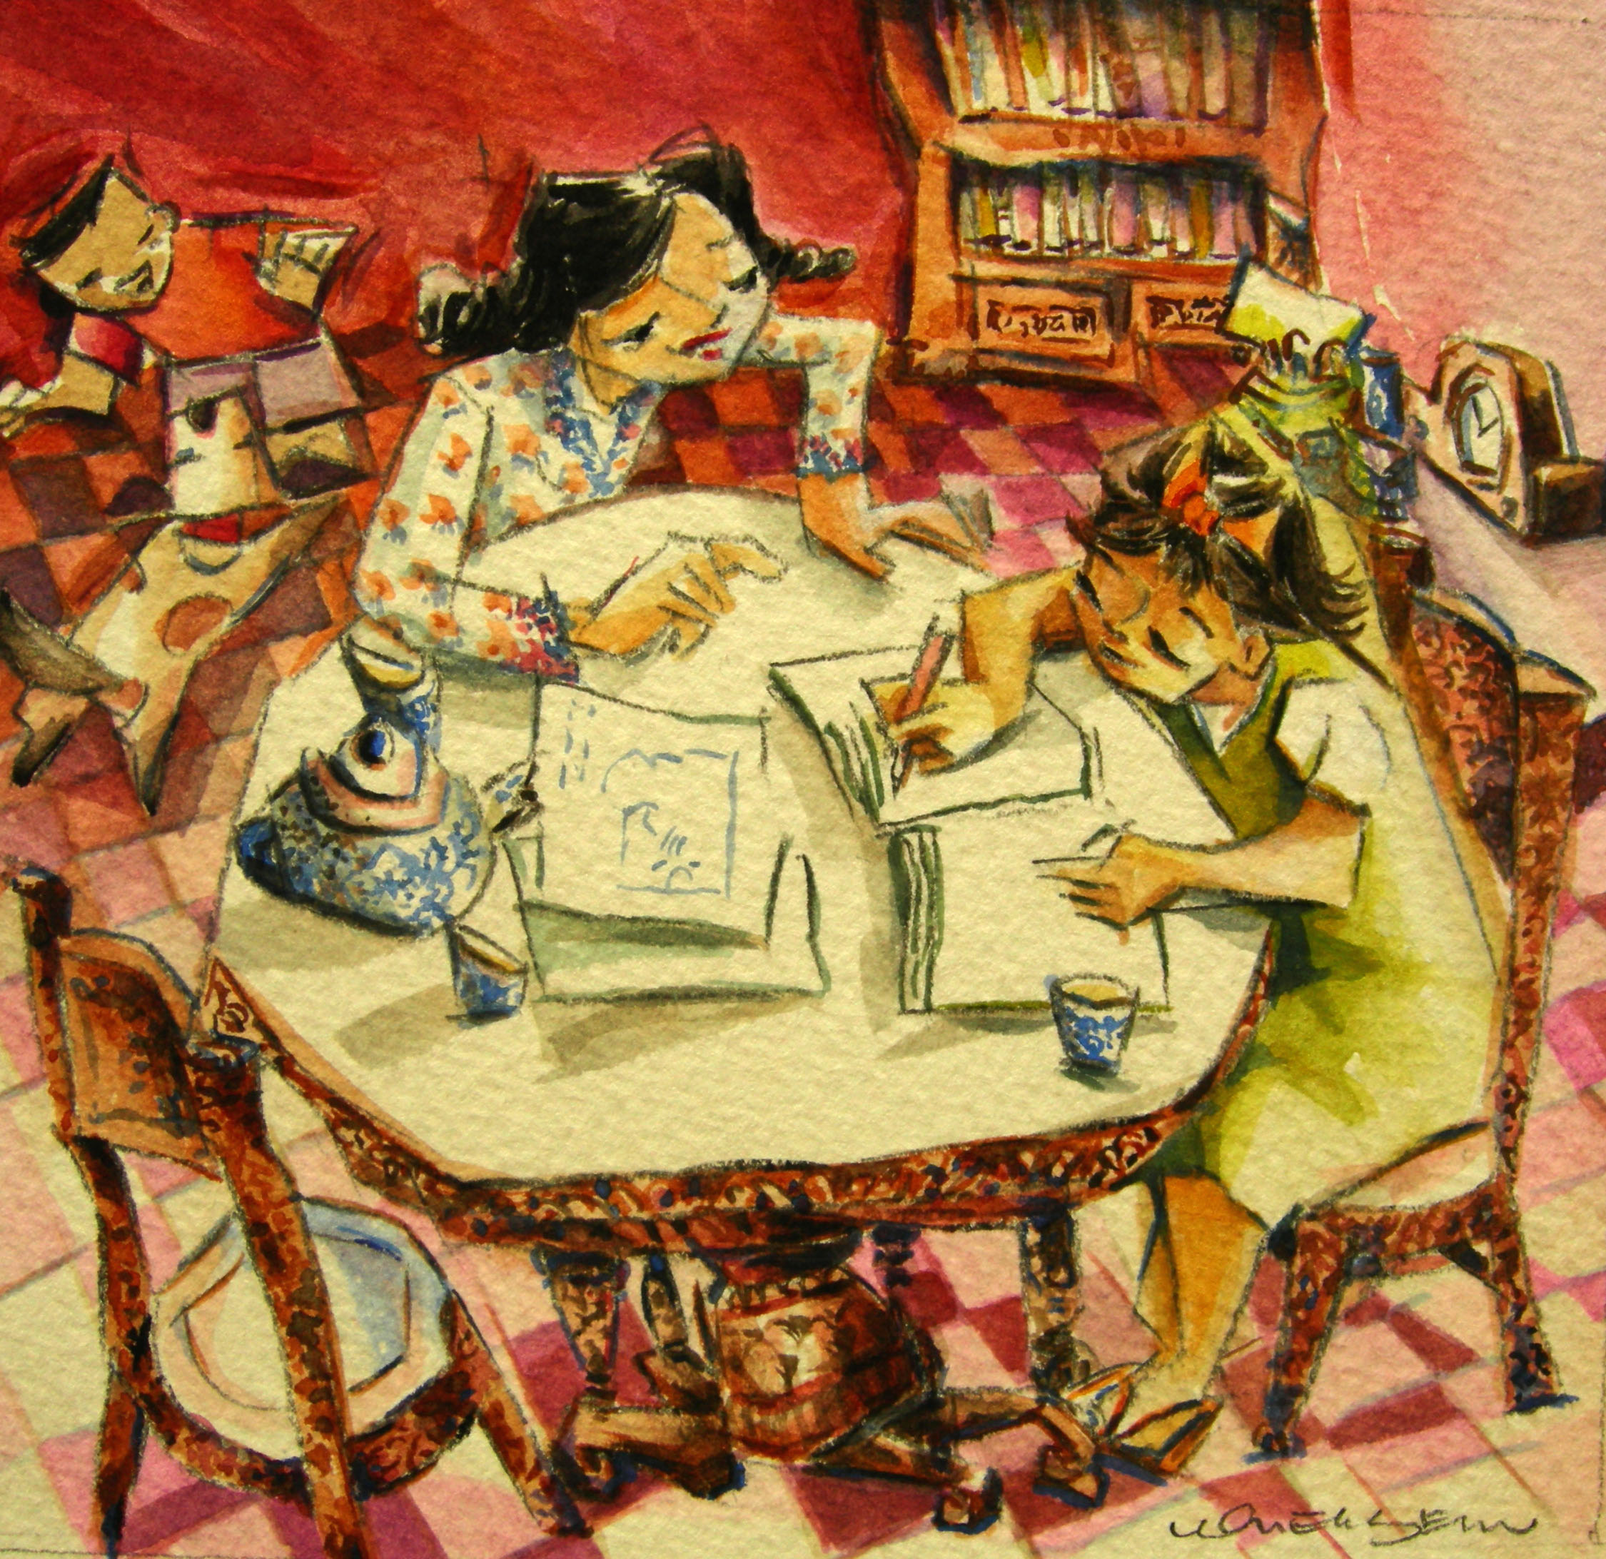
Home Tutoring
In more conservative homes, school was out of the question for girls once they reached 12. A woman’s place was believed to be within the house. If the parents had any misgivings about this, they would engage a female tutor or teach their daughter themselves.

